**WEEK - 2**

**Day -1 : 22 January 2024**

***Holiday***

**Day -2 : 23 January 2024**

**Task -1 : reactcssone**

**Code :**

*Index.js*

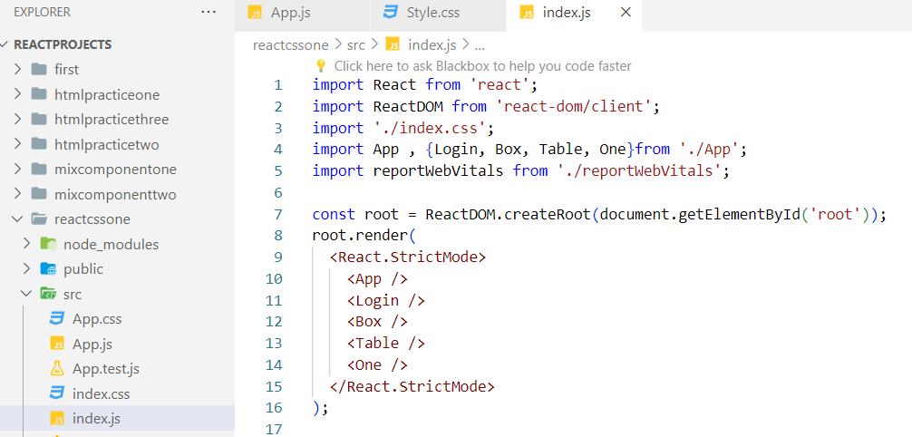

*App.js*

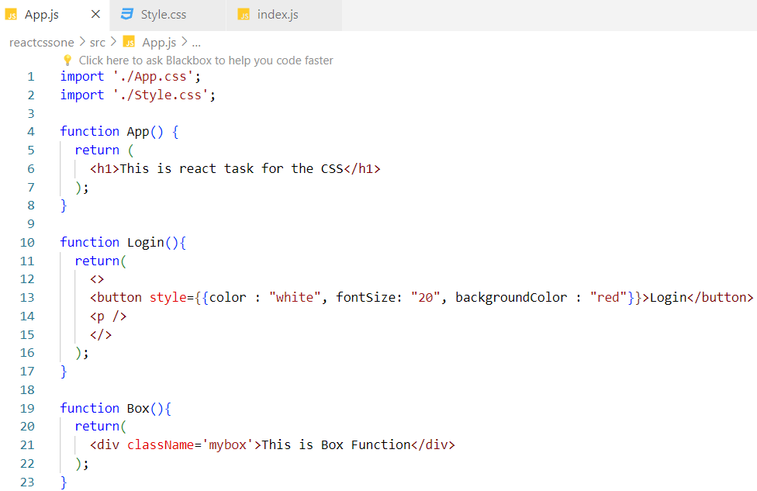

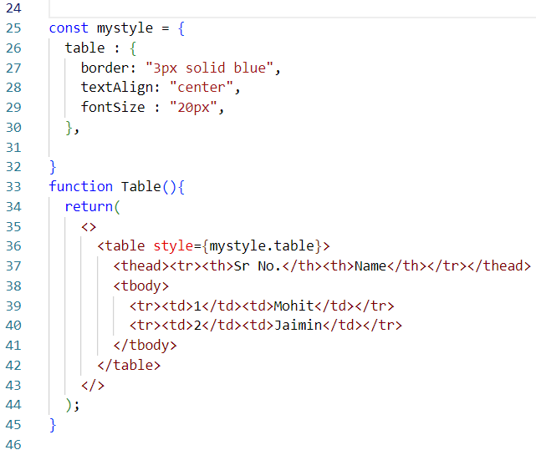

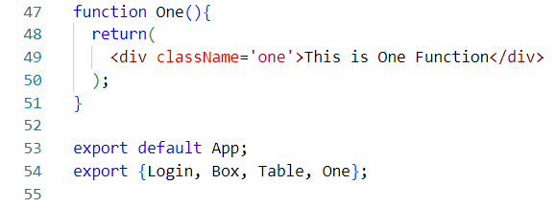

*Style.css*

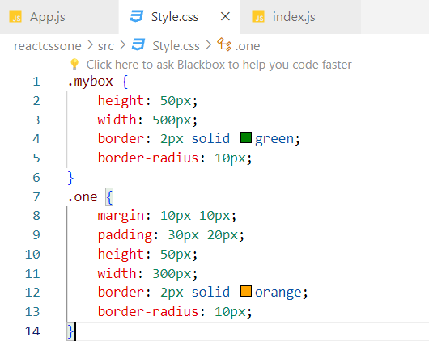

**Output :**

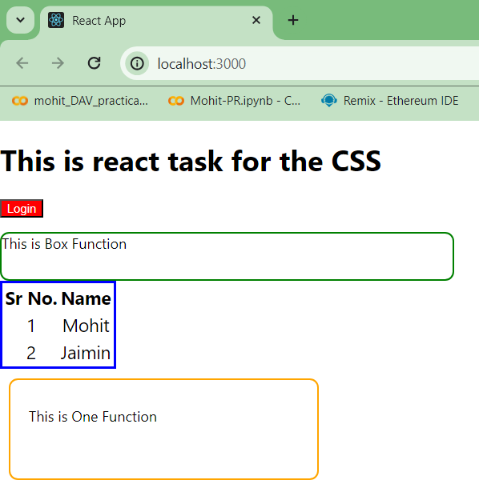

**Day- 3 : 24 January 2024**

**Code : imagegallery**

*Table.js*

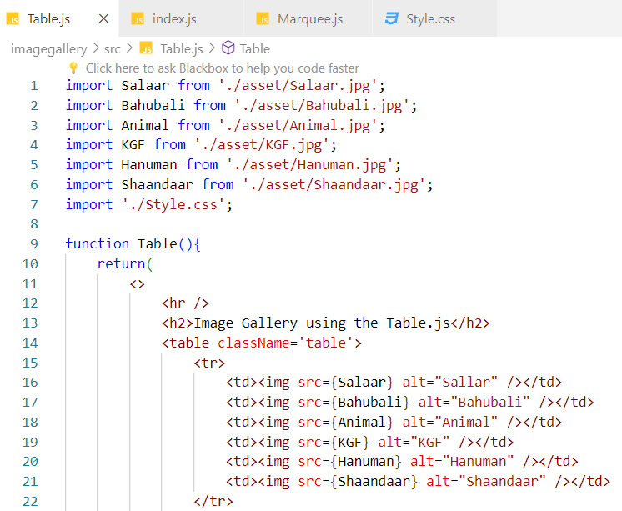

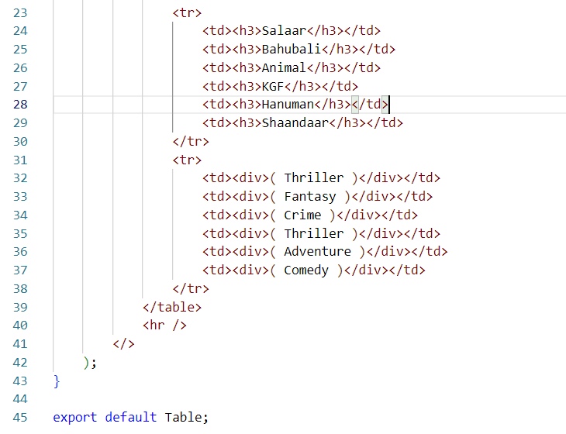

*Marquee.js*

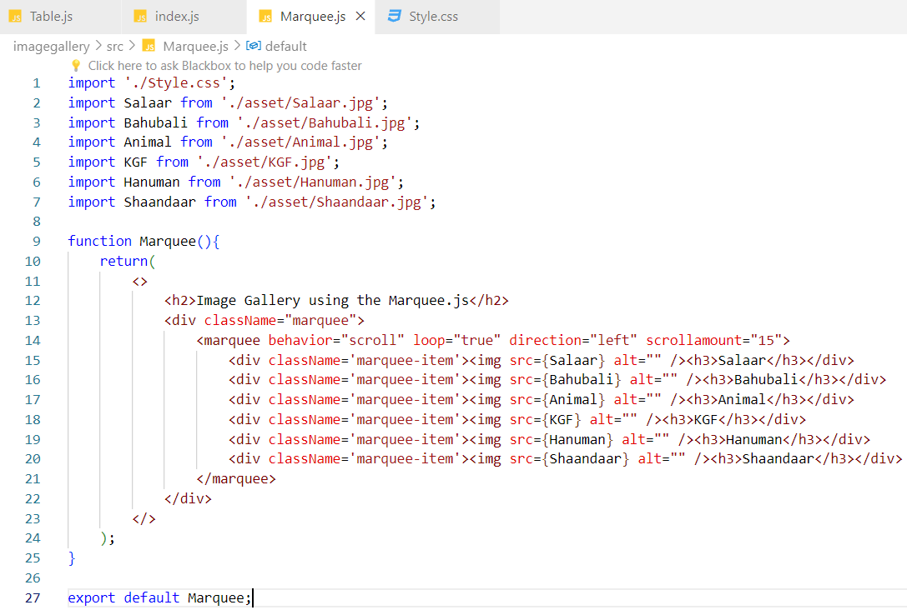

**Output :**



